choice of fries, tots, chips, coleslaw
CHEESY
american cheese, lettuce, tomato, onion, kosher pickle spear 11
SMASH
smashed patty, swiss & american cheese, thousand island, caramelized onion, rye bread 11
FIRE
chorizo, guacamole, chile relleno, pepper jack cheese 12
B.O.M.B
brie cheese, caramelized onion, portabella mushroom, bacon, pumpernickel roll 13
ELLYN’S
blue cheese, bacon, fried egg, lettuce, tomato, onion 13
CHI TOWN
giardiniera, roasted red pepper, caramelized onion, provolone 12
PADDY
burger patty, corned beef brisket, swiss cheese, slaw, russian dressing, 14

*Sub a veggie patty for any of the above burger
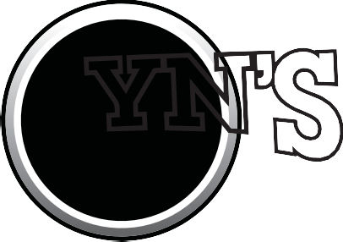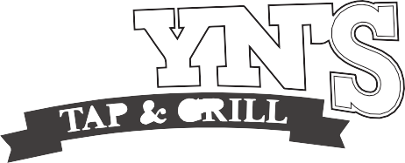

WINGS
classic or boneless:
buffalo, thai chili, bbq, pineapple-habanero
seven: 8 twelve: 13

TOT POUTINE
gravy, duck bacon, green onions, cheddar cheese 7

TEMPURA ONION RINGS
wasabi dipping sauce 7

ITALIAN BEEF EGG ROLLS
italian beef, giardiniera, spicy queso, monterey jack, au jus 8

PIEROGIES
potato-cheddar pierogies, bacon, sauerkraut, dill sour cream 7

BAVARIAN PRETZELS
honey mustard, spicy cheese sauce 7

NACHOS
tortilla chips, cheese, ranchero beans, lettuce, guacamole, jalapenos,
sour cream, salsa 8
chicken 3, pork 3, short rib 5

CRISPY PICKLES
sriracha-spiked ranch dipping sauce 6

QUESADILLA
jack, cheddar, havarti cheeses, pico de gallo, sour cream 8
chorizo 3, chicken 3, pork 3, beef short ribs 5

POTATO CHIPS
parmesan cheese, herbs, sriracha ranch 6

CABRA
baked goat cheese, chorizo, zesty tomato sauce, garlic bread 8

GUAC
crispy tortilla chips, house made guacamole, salsa 7

HOUSE
mixed greens, grape tomato, red onion, cucumber, white balsamic 5

CAESAR
romaine, caesar dressing, grape tomato, red onion, parmesan, croutons 7

KITCHEN SINK
lettuce, ham, grilled chicken, cucumbers, black olives, red peppers, asparagus, onions, artichokes, swiss, red wine vinaigrette 12

BLT CHOPPED
greens, avocado, bacon, tomatoes, croutons, eggs, buttermilk ranch dressing 8

CUP 4 | BOWL 5.5

three to a plate & side of rice

CHIPOTLE CHICKEN TINGA
braised chicken, avocado, pico de gallo, cilantro, crema, queso 11

VEGGIE
portobello mushroom, zucchini, peppers, romaine, goat cheese, avocado 10

MAHI MAHI
romaine, pico de gallo, avocado, remoulade, ﬂour tortillas 13
SHORT RIB
cilantro, queso sauce, pickled red onions, salsa 13

choice of fries, tots, chips, coleslaw

PULLED PORK
pulled pork, hickory smoked bbq sauce, bread & butter pickles, slaw 11
GRILLED CHEESE
cheddar, smoked gouda, provolone, havarti, applewood bacon, apples, honey 11
PORKER
kielbasa, pulled pork, bacon, provolone, slaw, pickles, cayenne mayo, bbq sauce 11

VEGGIE MELT
grilled zucchini, red pepper, portobello, provolone cheese, tomato, arugula, mayo 9

REUBEN
swiss cheese, thousand island, sauerkraut, pickle spear, marbled rye 11

LONGHORN
grilled chicken, havarti cheese, bacon, lettuce, tomato, garlic aioli 11

QUACK
duck bacon, sunny egg, baby greens, tomato, cheddar cheese, aioli, pumpernickel roll 10

POT ROAST
braised beef, brie, horseradish cream, sweet onions, gravy, pumpernickel roll 13
TEXAN
smoked beef brisket, cheddar cheese, onion rings, pickled jalapeno, bbq sauce 13

BUFFALO
crispy chicken, buffalo sauce, buttermilk ranch, blue cheeses, lettuce, tomato, onion 10

GOBBLER
turkey, ham, lettuce, tomato, swiss cheese, avocado, honey mustard 11

MAXWELL
grilled polish sausage, sauerkraut, griddled onions, mustard, new england roll 9

FISH FRY
beer-battered cod, fries, coleslaw, tartar sauce 13

MEAT LOAF
bacon smashed potatoes, garlicky green beans, red wine sauce 14

VEGGIE MAC
asparagus, red peppers, mushrooms, tomato, zucchini, pasta, cheese 13

CHICKADEE
grilled chicken breast, bacon spiked brussel sprouts, rice, chicken gravy 14

SALMON
green beans, asparagus, red pepper, brussel sprouts, dill butter 15

BACON MAC ‘N CHEESE 6 TOTS OR FRIES 4 ASPARAGUS 6 RICE 4
BACON SMASHED POTATOES 5 GREEN BEANS 5 BRUSSEL SPROUTS 6

